Under kitchen sink  1. | On plant pot in _________ (room) | On Banister  15. | Behind main TV in house  21.
On shampoo bottle  2. | Inside airing cupboard  8. | Next to ice cream in the freezer  16. | Under kitchen bin  22.
In vegetable draw in fridge | In _______’s coat pocket  10. | Behind knife block  9. | Under sofa cushions  23.
Under Kettle  4.  3. | On Bookshelf in _______’s  11.  (room) | On lamp by _______’s favourite chair  24.  17. | Return to Computer
Under ________’s bed  5. | In _______’s school shoes  12. | On cereal box | (Spare)
Behind printer  6. | Behind mirror in _______’s  13.  (room)  14. | On  19.  18.  _________ (location)  Toilet | (Spare)
Behind  7.  _________ (description)  picture | On baked bean tin | Under chair in Kitchen  20. | (Spare)
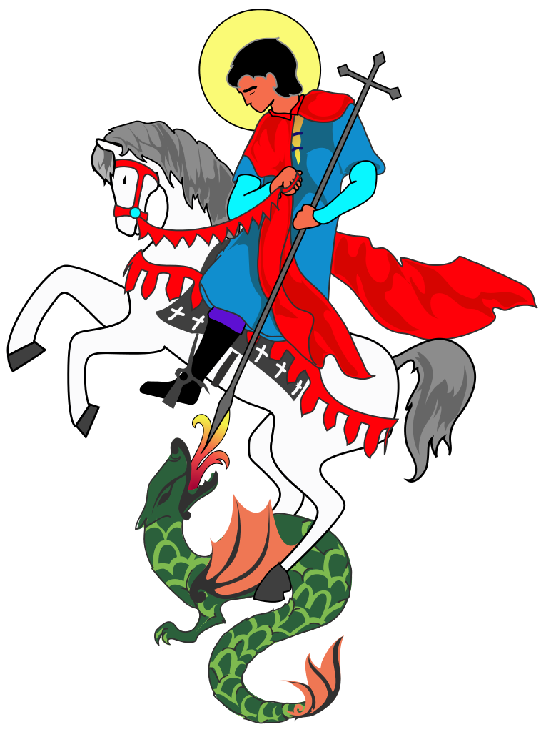
Dear Parents,
Please can you help me prep a game for Scouts in advance of next troop meeting…
I want to run a treasure hunt during the online meeting.
Can you cut out and sellotape these clues around your house ready for the troop night – you may need to write in locations in the “___________” areas to be more specific.
Start with the last clue and work backwards. Place the last Red clue number 24 [Return to Computer], under the sofa cushion. Then place clue 23 [Under Sofa Cushions], under the kitchen bin. Carry on working backwards so that the previous clue point to where the next clue is located. Once you have placed clue number 2 [On the Shampoo bottle] under the kitchen sink. You are done! I will give the first clue live on air on Thursday night to start the mad treasure hunt around your house (There is no need for you to use the first clue – I will give them that).
The scouts will need to collect the clues and arrange the picture back infront of the zoom meeting. Whoever tells me the what the picture is first, wins.
I will leave you to do the sneaky bit and hide up the clues so they are unaware of their impending challenge.
Much appreciated and good luck at being sneaky.

