Best of Luck!  Good luck with whichever badges you choose to complete.  There are also more badges available so please take a look on scouts.org.uk  And remember you can contact us via email at any time if you have any questions or want to share your awesome work!  Yours in Scouting,  ________________ |  |  | Scouts  Badge Workbook

Contact us

Email:

Facebook:

If you’d like to enjoy some scouting activities at home, this booklet will give you ideas of badges that can be completed away from the Troop.  Choose the one(s) that interest you the most and complete all of the requirements listed. There will be various ways to show us you have completed your badge, it could be:  - Sending photos to us  - Worksheets  - Short videos sent to a leader of you demonstrating a new skill  Badges are flexible, and if you can show you have completed badge requirements in your own way that’s great!  Please choose to complete badges that you haven’t already earned with us, as unfortunately we cannot award the same event twice,  If you have really enjoyed one of your activity badges, you can earn an “Activity Plus” badge, to do this you must agree on some requirements together with your leaders for you to complete and earn an “Activity Plus” badge.  If you have any questions about completing a badge, or you’re not sure about something, please ask your parent/guardian to contact us and we’ll always try to help you. | 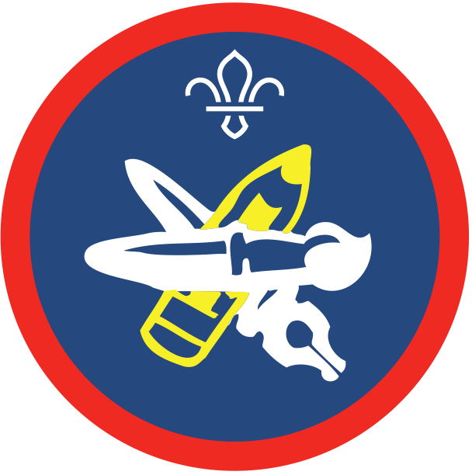  Artist
- Paint, draw or illustrate each of these:

    - a scene from a story
    - a person or object
    - a landscape

- Show a selection of your own recent work.

Arts Enthusiast | Chef
- Choose a favourite art form or artist to take an active interest in.  It doesn’t have to be painting – it could be pop music, sculpture, theatre, architecture, break dancing or anything similar.  - Describe two visits you have made that are connected to your interest.  You can use photographs, films, recordings, concert programmes, ticket stubs, newspaper reviews or websites to illustrate your point.  - Show that you know a lot about an aspect of your interest.  You could talk about a particular piece of art, like a painting, performance, sculpture or building. Or you could discuss a particular person or historical period connected with your chosen art form.  - Make a list of major events, exhibitions or venues connected with your chosen subject.  Talk about why the items on your list are important. | - Plan a menu for a weekend event for between four and six people.  Include the quantities you’ll need and any dietary needs of the group for cultural, religious or medical reasons.  - Show how and where to shop for the food and the best way to transport it.  - Show how to store food properly, hygienically and in ways that prevent food poisoning.  Explain what you might need to consider if you’re using an indoor kitchen or a camp kitchen.  - Cook and serve at least one of the meals from your menu.  The meal must be at least two courses and can be prepared on an open fire on camp or in a kitchen.  - Demonstrate the best way to clear up afterwards.  Clearing up should include washing up utensils, pots and pans, disposing of rubbish and leftover food in a way that prevents vermin or disease.
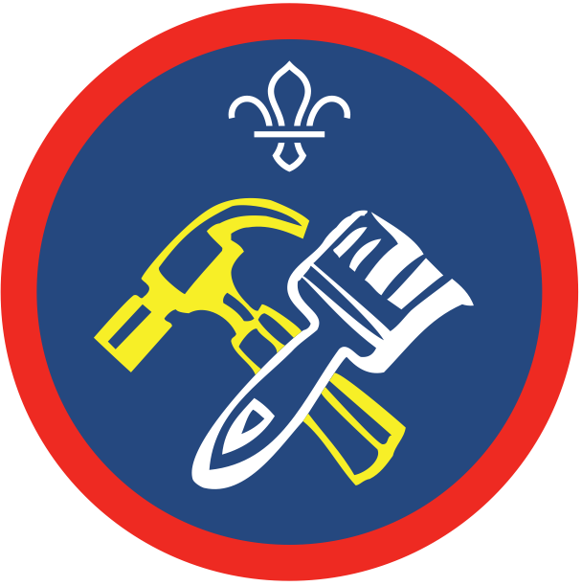  DIY | Equestrian
- Show you can work safely and know about the following:  - hazard symbols and signs (for dangers such as toxic, flammable, irritant, electrical danger or slippery surface)  - safety equipment (such as goggles, gloves, masks, ear defenders)  - how and where to turn off mains supplies (such as water, electricity and gas) to the house.  - Learn how to safely isolate individual electrical circuits at the consumer unit.  This includes letting other users know that work is being carried out  - Show or explain how you would deal with four DIY emergencies.  For example:  - unblocking a sink  - adjusting the float arm of a cistern  - changing a lightbulb  - hinge a door back in place  - fixing a doorbell ringer  - repairing a tear in clothes or upholstery  - removing common stains eg ink, wine, and coffee  - Take an active part in two major DIY projects, indoors or outside.  You could:  - prepare and paint, paper or tile the walls of a room  - prepare and paint woodwork or furniture  - fit a curtain track and hang curtains  - hang a door and fit or repair locks and other door furniture  - Alternatively, you could do any other projects of a similar skill level.  Agree what you’ll do with an adult who is skilled in the relevant areas. | - Riding  - Show you can catch a pony from a field or stable and tack up for riding.  - Walk, trot and canter a pony.  - Jump over small fences.  - Grooming and care  - Groom your pony correctly and explain why it is necessary.  - Show you know how to take care of saddlery and other equipment.  - Horse health  - Find out about some of the basic health issues affecting horses and ponies, including worms and laminitis.  - Show you have a basic knowledge of grass management.  - Show you recognise poisonous plants and the results of overgrazing.  - Safety  - Talk about road safety for riding.  - Explain why you need a hat, body protector, stirrup and other safety equipment.
Farming | Small Holder
- Learn about farming practices in your area.  - Find out about the organisation, as well as the daily and seasonal operations, of a farm of your choice.  Make a note of practices relating to livestock, crops, cultivation, rotation, machinery and labour force.  - Find photos to demonstrate the changes in farming practices that have taken place over a number of years.  Explain the reasons for these. | - Cultivate an area of garden or an allotment for a specific length of time.  Agree this beforehand with your leadership team.  - Show you’re successful in growing:  - three kinds of hardy annual flower  - three kinds of vegetable  - two kinds of bulbs, herbaceous plants, flowering shrubs or rose  - Keep a record of the work you've done and the results you've achieved.  This could include height records of the flowers, for example.
Global Issues | 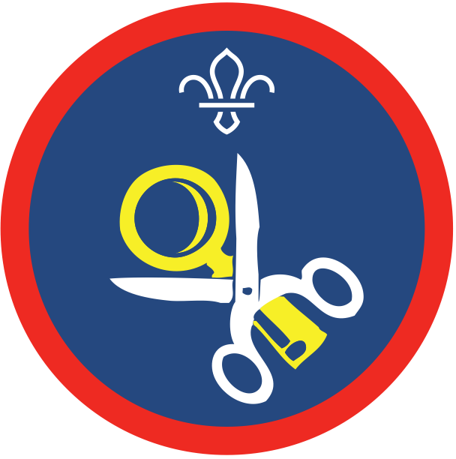  Hobbies
- Identify where your clothing or other belongings have been made.  With other Scouts, talk about why companies might choose to have the items made in other countries. What are the advantages and disadvantages of overseas production?  - Investigate a recent natural disaster by looking at photos, news articles or videos online.  Decide in small groups what five things were needed to help people after the disaster. Decide as a Troop how best you can help when a natural disaster happens.  - Find out about an international sporting event and discuss with your Troop how sporting events can contribute to international peace and understanding.  - Learn about an international health issue and use a creative way to share what you have learnt with your Troop.  Issues could include Malaria, Ebola, HIV and Aids.  - Think about the rights that we have in the UK (like the right to vote, the right to go to school and equal gender rights).  Compare these with the rights a Scout in another country might have. | - Option 1:  - Take up a hobby or interest that you do not already have an activity badge for.  - Keep a record of your hobby for at least four months.  - Option 2:  - Make a collection or study of objects for at least four months.  You could collect books or magazines, films, cards, key rings, figurines or similar.  - Talk to your Patrol Leader or your Troop about the collection or study you chose.  Explain why you chose your objects and what you like about them.
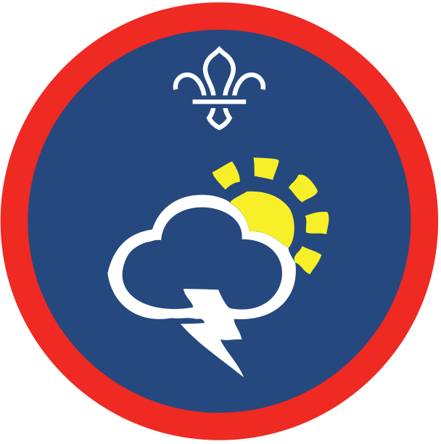  Meteorologist | Model Making
- Explain how each of these are measured:  - wind force and direction  - cloud type and extent  - temperature  - pressure  - rainfall  - humidity  - Record the weather conditions every day for two weeks, or once a week for three months.  Use equipment like a rain gauge or an outdoor thermometer.  - Identify different cloud types.  Describe how they are formed.  - What do ‘warm’ and ‘cold’ air masses in summer and winter do to the typical weather in your area?  Describe the effects on land and sea.  - Explain how weather forecasts are created.  - Show that you understand a synoptic weather map, including fronts and isobars.  Explain how the measurements in step 1 relate to the map. | - Choose one of these activities:  - Build a model using a plastic or white metal kit or pre-cast figures.  - Design and construct a model from a wood, plastic or metal construction set, such as Lego or Meccano.  - Show that you know the different types of kits or parts available in the material you chose.  - Talk about the experience of building the model with a knowledgeable adult.
My Faith | 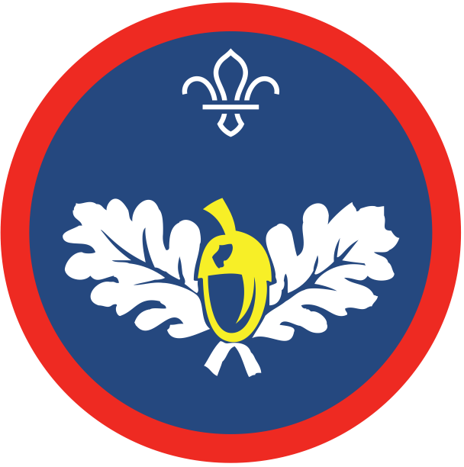  Naturalist
- Take an active part in your place of worship.  You could get involved in community work, take a special part in services or celebrations or follow a training or study programme.  - Find out more about the origins of your faith.  Share what you find out with others in the Troop.  - Explore something about the history of your faith at a local, national or international level.  You could learn about influential people, or visit a shrine or other holy place.  - Explain to an adult some of the teachings of your faith.  Explain how these affect the way you live your life. | - With appropriate permission, spend at least one day at one of these locations and investigate the wildlife and plants found there:  - woodland or parkland  - down land  - moor land  - seashore or sand dune  - hedgerow  - roadside verge  - stream, river or canal  - small pond  - wetland or marshland  - Tell a knowledgeable adult what you discovered.  Show them your field notes, sketches, photographs or maps.  - Find out more about a plant, animal or particular wildlife from your chosen location.  - Discuss what you found out, giving sources for information from places like museums, field guides or the internet.  - Discuss how human activities or land management can affect wildlife.
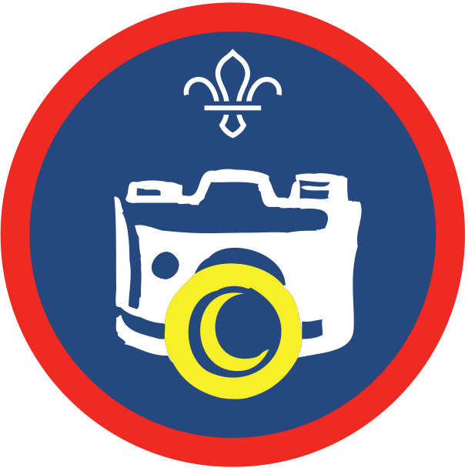  Still Photography | Video Photography
- Choose one of these two activities:  - Produce 12 photographs, featuring at least two of these photographic techniques: portrait, still life (or similar), landscape or seascape, sport or action, or timelapse.  - Produce six black and white photographs, based on a theme of your choice. Explain the steps you took to create them and the impact of using black and white as an alternative to colour images.  You could produce high quality prints on photographic paper or present them on screen.  - Show that you know the main settings on a digital camera or a smartphone camera.  This should include focus and exposure control, and flash settings. Explain the impact of shutter speed and aperture size on the image.  - Describe what accessories are available to use with digital cameras or smartphone cameras.  - Edit a selection of your images, using editing software on a computer or using an app on a smartphone.  This could include cropping, colour, contrast or light levels. Explain what you have changed and how it improved your image.  - Diagnose typical faults that happen at the photographing or editing stages, such as over or under exposure and high or low contrast.  Explain how to reduce camera shake and how to respond to subject movement.  - Show that you know how to care for a digital camera or smartphone camera. | - Produce at least two short films from two of these categories.  - documentary  - music video  - drama  - comedy  - advertisement  - training film  Create a storyboard and script for each of these. Edit the film using editing software on a computer or a smartphone app.  - Show that you understand:  - camera techniques such as panning, zooming, close-ups, long shots and using additional lighting  - production techniques such as editing, how to avoid jump cuts and maintaining continuity.  - Choose one of these two activities:  - Show that you know how to care for a video camera and accessories, such as storage media, batteries, microphones and lights  - Discuss the differences between recording video on a video camera, digital camera and a smartphone.

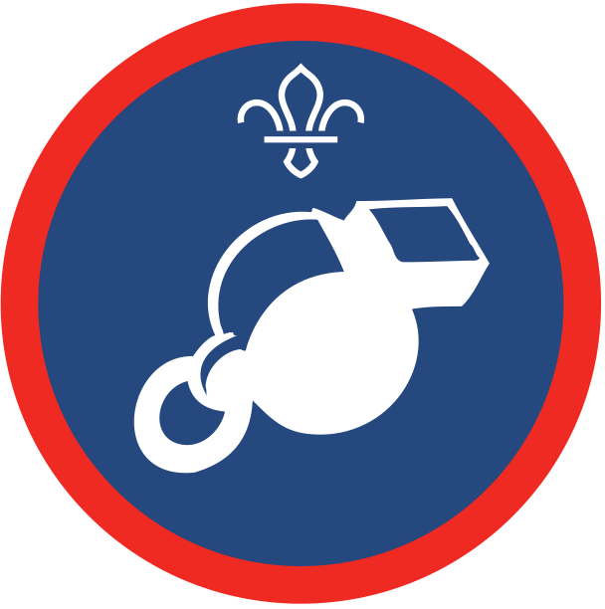  Physical Recreation | Pioneer
- Regularly take part in an active sport or physical pursuit, which you haven’t already gained an activity badge for.  It could be a team game like rugby, football or water polo.  Individual sports like tennis, running or gymnastics count too, so do pursuits like walking, yoga, ice skating or dancing.  - Show a reasonable level of skill in your sport or pursuit.  Show how you’ve improved over time.  - Explain the rules or guidelines that govern the sport or pursuit you chose.  - Show how you would prepare before taking part in your sport or pursuit.  You could run through any special equipment or clothes you need and any warm-up and warm-down routines.  - Explain how to care for the equipment you use.  Explain what you should look out for when the equipment is nearing the end of its life. | - As a member of a group, take part in:  - an indoor pioneering project, like constructing a guided missile launcher or chariot  - an outdoor pioneering project, like building a monkey bridge, a raft or parallel runway  - Show the correct way to do these:  - a whipping or safe rope sealing  - a splice  - coiling and storing a rope  - using levers to extract objects or move heavy weights  - being safe in pioneering projects. Explain why it’s important.  - Name and tie at least six knots and three lashings that are useful in pioneering.
Scientist | 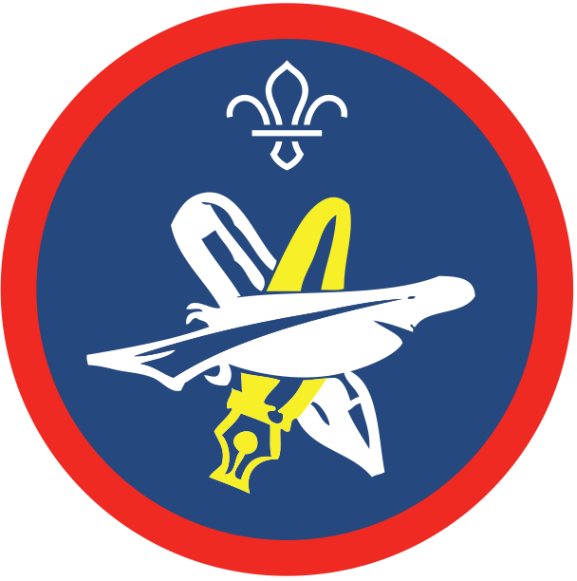  Writer
- Plan and complete three science experiments or activities. Check your plan with an adult first, then for each experiment:  You could try making invisible ink, creating an eruption, designing a catapult or putting together a battery.  - Change something about the experiment or activity and try it again, at least once. Predict what you think will happen and find out if you were right.  - Show that you understand the science behind your experiment or activity.  - Find out how one of your experiments or activities links to the real world. Then, explain it to others.  For example, if you made a battery, what are batteries usually made from? If you created an eruption, how similar or different is this to how volcanoes erupt? | Complete four of the following:  - Compose a poem of at least eight lines.  Discuss its meaning and construction.  - Create a short story of around 600 words.  Talk about your story idea with an appropriate adult beforehand.  - Write a descriptive passage of around 600 words on a subject, agreed with an appropriate adult beforehand.  - Write a 600-word review of a favourite book, play or other work of literature and talk about it with an appropriate adult.  - Produce a published article of around 600 words in length.  You could contribute to a school, faith, community or Scout magazine or write a letter to a local paper.  - Keep a diary on a subject, for a length of time agreed with an appropriate adult beforehand.  - Write a play or dramatic sketch lasting at least 10 minutes.  - Interview a local celebrity, or other notable person.  Write or type out the interview to show the questions you asked and the interviewee’s replies.  - Write a letter to a pen pal (real or imaginary) of at least 600 words.

